**SCRUM MEETINGS**

**TOOLS USED**

* Team co-ordination: Taiga Project Management
  + <https://taiga.io/>
* XP programming practice
* Continuous Integration: Jenkins
* Test Coverage tools

**SPRINT 1**

**Scrum Master: Raj Kiran Reddy Gunna**

* Goals
* Creating a Simple QBMS GUI design
* Required features for the project
* Product backlog
* Required tools and installation
* DB schema and DB diagram
* Achievements
* Setting up taiga
* Creating product backlog
* Team collaboration
* Discussion on basic features of the project
* Creating DB schema and DB diagram
* Backlogs
* Features for the project
* Contents on GUI Design

**SPRINT 2**

**Scrum Master: Sefak Kahriman**

* Goals
* Setting up Repository for everyone
* Discussion on Web Content
* Discussion on DB tables and its contents
* Discussion on required tools as Hibernate and JBoss
* Working on User Registration page
* Working on adding Courses
* Achievements
* Setting up Oracle Database
* Changes on DB schema
* Creating DB Tables
* Discussion on Database
* Backlogs
* Oracle Database
* Hibernate and JBoss
* DB Schema and DB Tables
* Installing oracle DB
* Couldn’t complete adding Courses

**SPRINT 3**

**Scrum Master: Christian Levi**

* Goals
* Installing MySQL
* Create basic Web contents
* User Registration page done
* Working on CSS files
* Working on DAO layer
* Working on QB features
* XP programming practice
* Achievements
* Installing Hibernate and JBoss
* Creating Web contents as Login, Answers and Questions
* Working on adding Courses completed
* CSS files completed
* DAO layer for the project is completed
* Backlogs
* Create Navigation bar
* MySQL DB
* Dashboard

**SPRINT 4**

**Scrum Master: Unni Krishnan**

* Goals
* Junit Testing
* Improving web contents
* Create Dashboard
* Achievements
* Changes on DB Tables’ attributes
* Creating Web content as Login, Answers and Questions
* Adding Entities to DB tables
* Backlogs
* MySQL DB
* Junit Testing
* Code coverage and find bugs plugin

**SPRINT 5**

**Scrum Master: Shiva Jyothi Angala**

* Goals
* Creating all web contents with all features
* Creating admin
* Adding Questions & Answers
* Admin view
* Junit testing for all classes
* Achievements
* Dashboard is finalized
* Logging in
* Creating Person
* Creating Questions/Answers
* Creating Web content as Login, Answers and Questions
* Side navigation bar added
* Backlogs
* Finalize web contents
* Creating PDF document
* Testing all functionality

**SPRINT 6**

* Goals
* web contents with all features
* PDF documentation
* Creating admin
* Junit testing for all classes
* Achievements
* Dashboard is finalized
* Download feature
* Creating Questions/Answers
* Creating Web content as Login, Answers and Questions
* Side navigation bar added
* Code coverage running successfully
* Bugs fixed through Find bugs
* Implemented pair programing
* Backlogs
* Quality testing
* Created PDF document
* Working on Invalid credentials
* Testing all functionality
* Validations

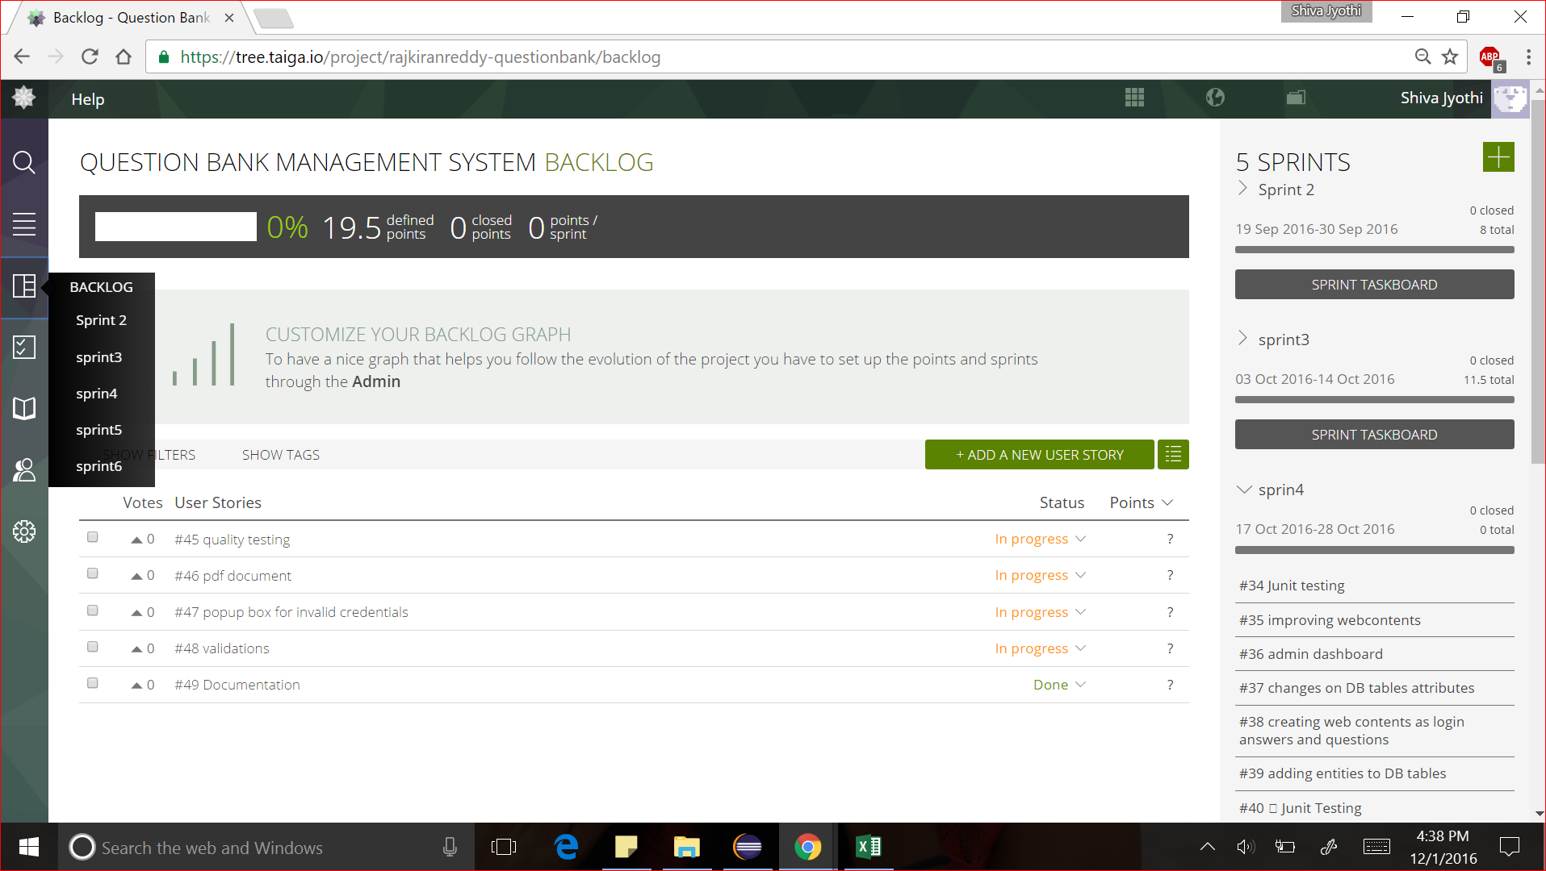

Taiga --- <https://taiga.io/>